 analyzing the exchange rate data for various countries/regions across multiple years.

The goal is to populate a summary table with these statistics and identify the trend of exchange rate stability or fluctuation based on specific criteria.

**Task:**

Your goal is to assess the stability or volatility of exchange rates for each country/region.

Work within the Exchange Rate sheet and input your final answers in the Solution sheet.

**Step 1: Analyze Exchange Rate Behavior**

For each country/region, carry out the following analysis:

1. **Average Exchange Rate:** Calculate the average exchange rate
2. **Central Exchange Rate:** Calculate the median exchange rate.
3. **Most Frequent Exchange Rate:** Calculate Mode.If no rate repeats, mark this as "None."
4. **Highest and Lowest Exchange Rates:** Calculate minimum and maximum values of exchange rate
5. **Exchange Rate Variation:**Calculate the range by making use of minimum and maximum values
6. **Exchange Rate Consistency(How close values are to the average): **Calculate standard deviation of exchange rates.
7. **Overall Fluctuation (Overall variation over time):** Calculate variance of exchange rate

Organize your analysis into the summary table given in the solution sheet with the following structure:

|  |  |  |  |  |  |  |  |  |
| --- | --- | --- | --- | --- | --- | --- | --- | --- |
| Country Name | Average Exchange Rate | Central Exchange Rate | Most Frequent Rate | Lowest Rate | Highest Rate | Variation (Difference) | Consistency | Fluctuation |
| Country 1 | Value | Value | Value (if any) | Value | Value | Value | Value | Value |
| Country 2 | Value | Value | Value (if any) | Value | Value | Value | Value | Value |
| ... | ... | ... | ... | ... | ... | ... | ... | ... |

**Note: List country/region names alphabetically.** For countries/regions where no most frequent exchange rate exists, fill in with "None." Handle any errors by filling in with NA.

**Step 2: Identify Exchange Rate Stability and Trends**

In this step, you'll fill the column titled **Exchange Rate Trend** of the summary table. Populate this column based on the following conditions:

1. **Stable Exchange Rate**: If std deviation **< 10% of the average**, mark as **"Stable Exchange Rate."**
2. **High Volatility**: If the range **(Max - Min) > 20 units** or **variation > 100 units**, mark as **"High Volatility."**
3. **Extreme Fluctuation**: If **Max > 1.5× Avg** or **Min < 0.5× Avg**, mark as **"Extreme Fluctuation."**
4. **Increasing Trend**: If the **median value > average**, mark as **"Increasing Trend."**
5. **Decreasing Trend**: If the **median value < average**, mark as **"Decreasing Trend."**

**Priority for Trend Labels:**

In cases where a country/region satisfies more than one of the above conditions, use the following priority to determine which label to assign:

1. Extreme Fluctuation
2. High Volatility
3. Stable Exchange Rate
4. Increasing Trend
5. Decreasing Trend

Example of the final result

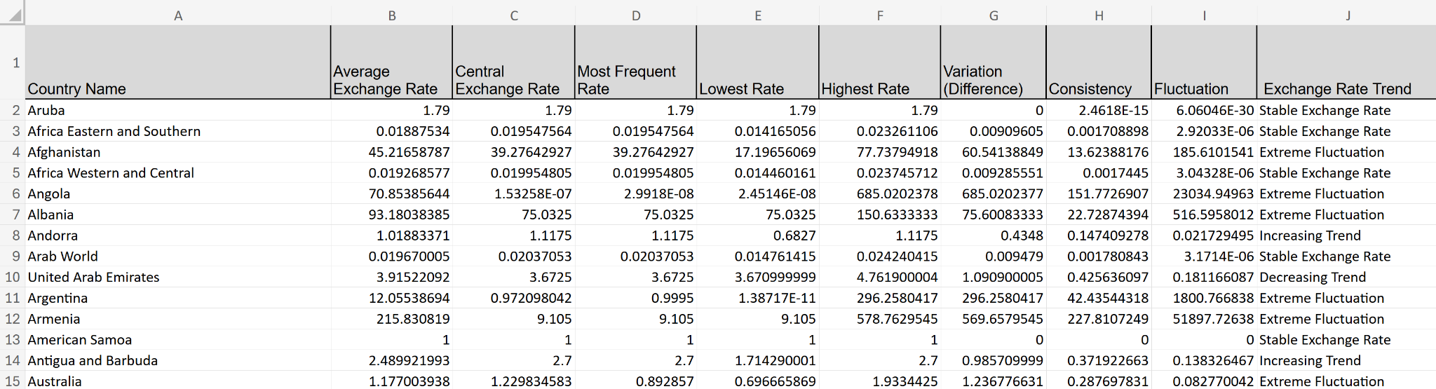

NOTE: Do not modify any of the given columns and rows.